四資工三甲 C108151131 賴冠綸

1. 程式執行畫面：
   1. 主選單（用以選擇第X小題）

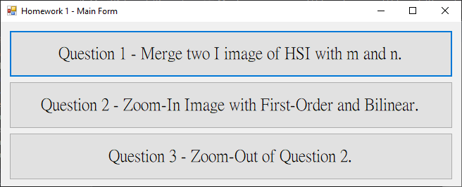

* 1. 第一小題
     1. m = 0.1, n = 0.9

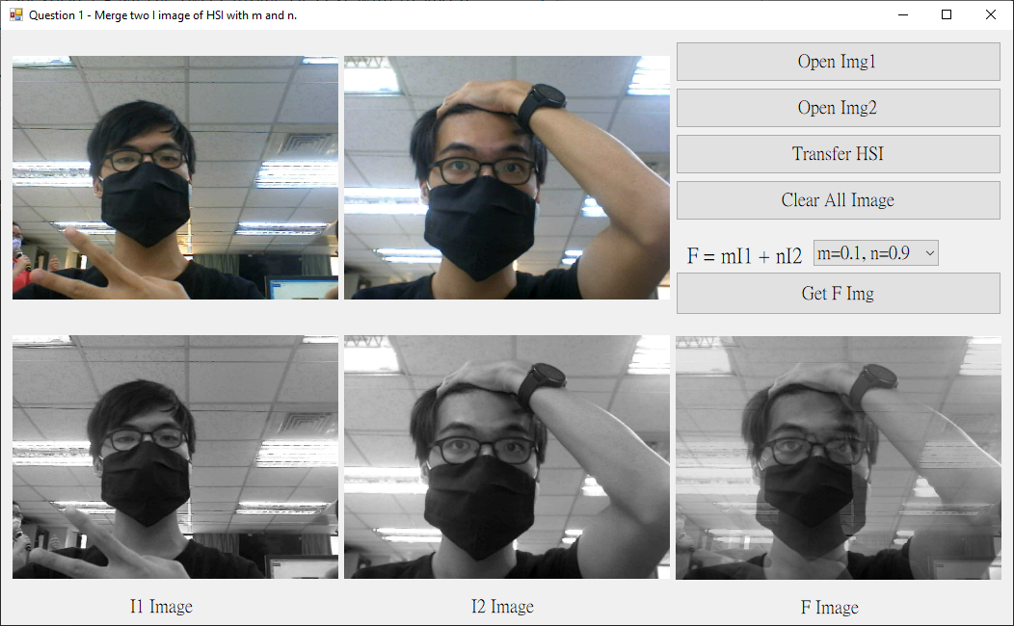

* + 1. m = 0.8, n = 0.2

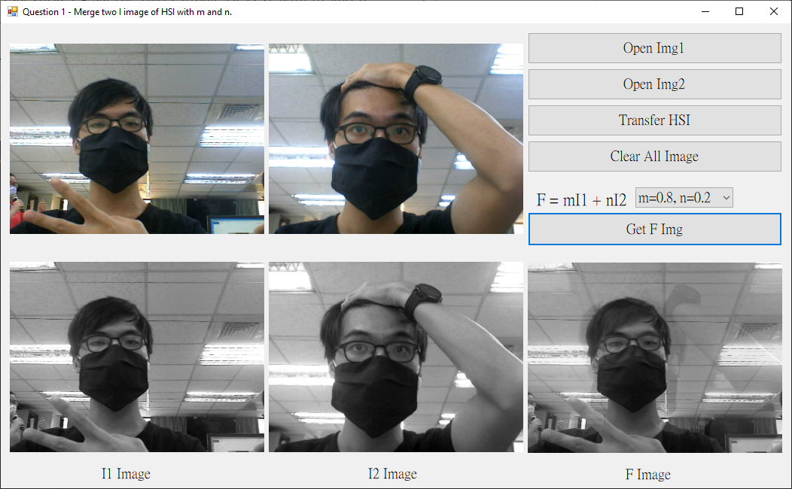

* 1. 第二小題 ─ 放大（除了First-Order與Bilinear，順便也比較了Zero-Order）
     1. 載入圖片後

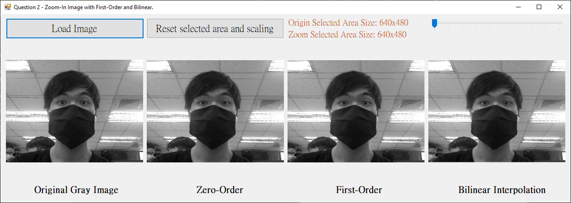

* + 1. 可以任意圈選範圍區塊（即時更新結果）

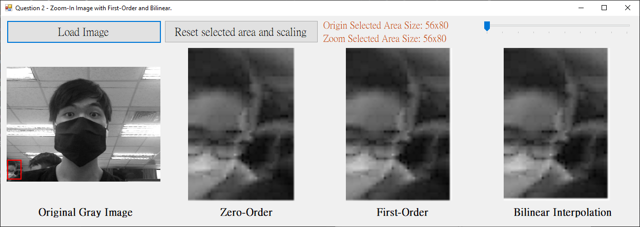

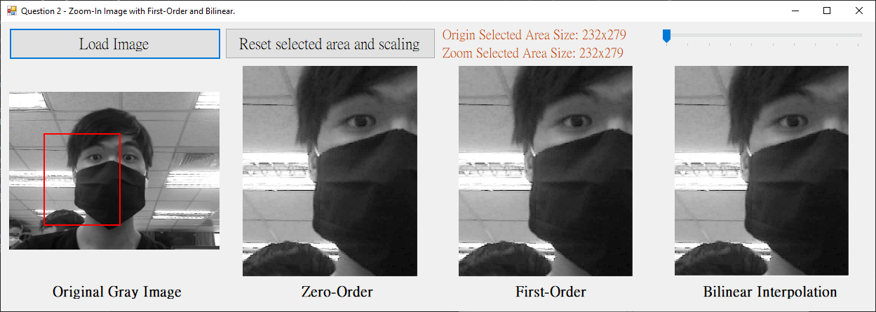

* + 1. 右上角的槓桿可以調整**放大**倍數

圈選範圍大小及放大後的大小皆會標示（棕色部分）

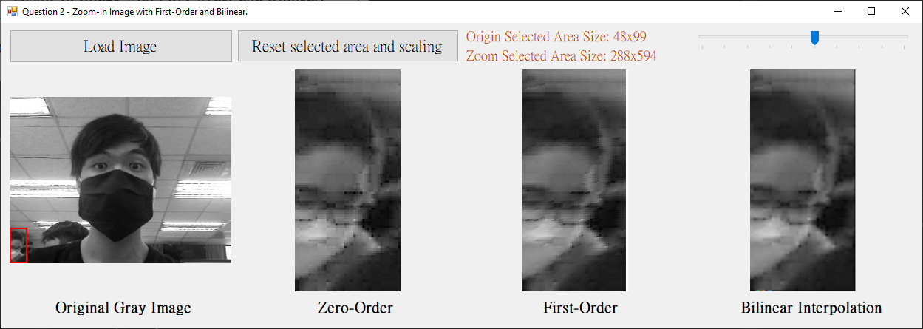

* 1. 第三小題 ─ 縮小
     1. 右上角的槓桿可以調整**縮小**倍數

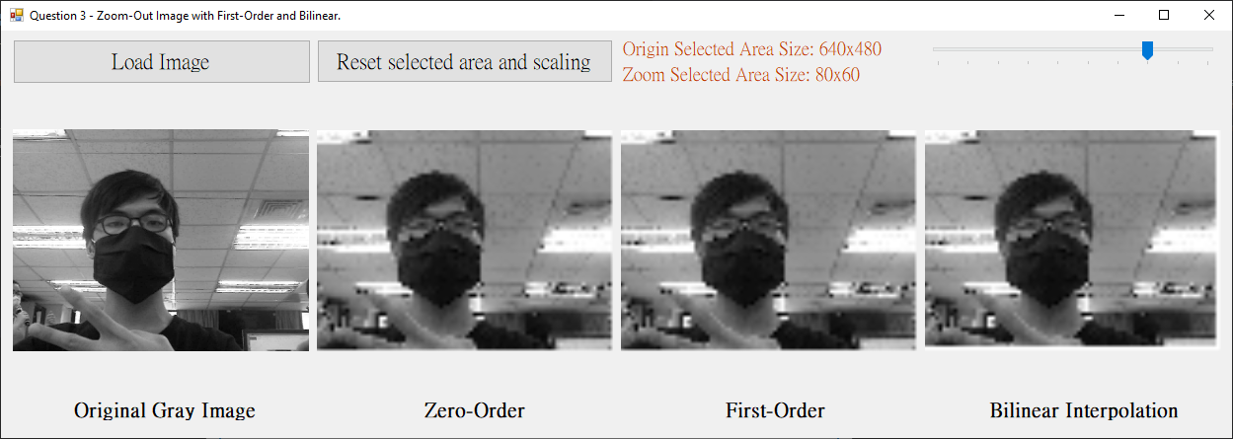

* + 1. 同第二題，一樣可以圈選範圍

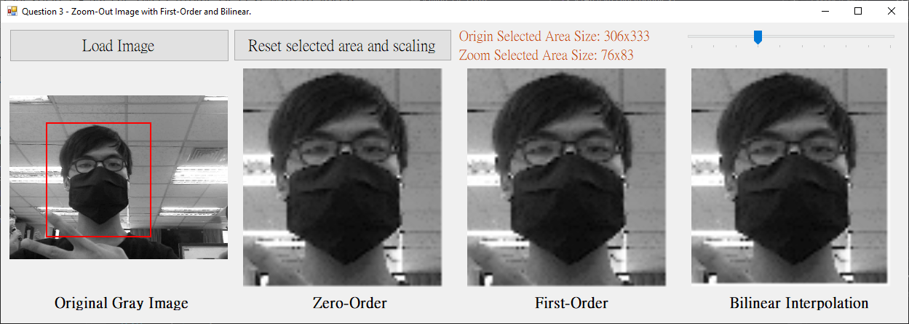

* + 1. 大部分功能皆與第二題相同

1. 程式碼（僅附主要程式碼）
   1. 第一小題
      1. 轉灰階（我將其包裝成一個Function，使其能重複被呼叫）

|  |
| --- |
| private: Bitmap^ Transfer(Bitmap^ rgb_img)  {  Bitmap^ gray_img = gcnew Bitmap(rgb_img->Width, rgb_img->Height, rgb_img->PixelFormat);  BitmapData^ bd_rgb = rgb_img->LockBits(Rectangle(0, 0, rgb_img->Width, rgb_img->Height), ImageLockMode::ReadOnly, rgb_img->PixelFormat);  BitmapData^ bd_gray = gray_img->LockBits(Rectangle(0, 0, gray_img->Width, gray_img->Height), ImageLockMode::ReadWrite, gray_img->PixelFormat);  /* Image maybe have unknown information */  int rgb_byteskip = bd_rgb->Stride - bd_rgb->Width * 3;  int gray_byteskip = bd_gray->Stride - bd_gray->Width * 3;  Byte* rgb_ptr = (Byte*)((void*)bd_rgb->Scan0);  Byte* gray_ptr = (Byte*)((void*)bd_gray->Scan0);  for (int y = 0; y < bd_rgb->Height; y++)  {  for (int x = 0; x < bd_rgb->Width; x++)  {  int pixel = ((int)rgb_ptr[0] + (int)rgb_ptr[1] + (int)rgb_ptr[2]) / 3; // I image    gray_ptr[0] = gray_ptr[1] = gray_ptr[2] = pixel;  // jump to next pixel  rgb_ptr += 3;  gray_ptr += 3;  }  // throw unknown inforamtion away  rgb_ptr += rgb_byteskip;  gray_ptr += gray_byteskip;  }  rgb_img->UnlockBits(bd_rgb);  gray_img->UnlockBits(bd_gray);  return gray_img;  } |

* + 1. 獲取合成影像F = mI1 + nI2

|  |
| --- |
| private: System::Void GetFImgBtn_Click(System::Object^ sender, System::EventArgs^ e)  {  float m; // n = 1 - m  switch (MN_comboBox->SelectedIndex)  {  case 0: m = 0.1; break;  case 1: m = 0.2; break;  case 2: m = 0.3; break;  case 3: m = 0.4; break;  case 4: m = 0.5; break;  case 5: m = 0.6; break;  case 6: m = 0.7; break;  case 7: m = 0.8; break;  case 8: m = 0.9; break;  default: return; // if haven't select  }  Bitmap^ I1_img = (Bitmap^)I1_Img_pictureBox->Image;  Bitmap^ I2_img = (Bitmap^)I2_Img_pictureBox->Image;  Bitmap^ result_img = gcnew Bitmap(I1_img->Width, I1_img->Height, I1_img->PixelFormat);  BitmapData^ bd_I1 = I1_img->LockBits(Rectangle(0, 0, I1_img->Width, I1_img->Height)  , ImageLockMode::ReadOnly, I1_img->PixelFormat);  BitmapData^ bd_I2 = I2_img->LockBits(Rectangle(0, 0, I2_img->Width, I2_img->Height)  , ImageLockMode::ReadOnly, I2_img->PixelFormat);  BitmapData^ bd_result = result_img->LockBits(Rectangle(0, 0, result_img->Width  , result_img->Height), ImageLockMode::ReadWrite, result_img->PixelFormat);  int I1_byteskip = bd_I1->Stride - bd_I1->Width * 3;  int I2_byteskip = bd_I2->Stride - bd_I2->Width * 3;  int result_byteskip = bd_result->Stride - bd_result->Width * 3;  Byte* I1_ptr = (Byte*)((void*)bd_I1->Scan0);  Byte* I2_ptr = (Byte*)((void*)bd_I2->Scan0);  Byte* result_ptr = (Byte*)((void*)bd_result->Scan0);  for (int y = 0; y < bd_I1->Height; y++)  {  for (int x = 0; x < bd_I1->Width; x++)  {  // F = mI1 + nI2  result_ptr[0] = m * (int)I1_ptr[0] + (1.f - m) * (int)I2_ptr[0];  result_ptr[1] = m * (int)I1_ptr[1] + (1.f - m) * (int)I2_ptr[1];  result_ptr[2] = m * (int)I1_ptr[2] + (1.f - m) * (int)I2_ptr[2];  I1_ptr += 3;  I2_ptr += 3;  result_ptr += 3;  }  I1_ptr += I1_byteskip;  I2_ptr += I2_byteskip;  result_ptr += result_byteskip;  }  I1_img->UnlockBits(bd_I1);  I2_img->UnlockBits(bd_I2);  result_img->UnlockBits(bd_result);  Result_pictureBox->Image = result_img;  F_label->Visible = true;  } |

* 1. 第二小題
     1. Zero-Order

|  |
| --- |
| private: Bitmap^ ZoomInImg_withZeroOrder(double k)  {  Bitmap^ selectedArea = GetSelectedArea();  Bitmap^ output = gcnew Bitmap(Math::Abs(endPos_real->X - startPos_real->X) * k  , Math::Abs(endPos_real->Y - startPos_real->Y) * k , selectedArea->PixelFormat);  BitmapData^ selectedAreaBD = selectedArea->LockBits(Rectangle(0, 0, selectedArea->Width, selectedArea->Height), ImageLockMode::ReadOnly, selectedArea->PixelFormat);  BitmapData^ outputBD = output->LockBits(Rectangle(0, 0, output->Width, output->Height), ImageLockMode::ReadWrite, output->PixelFormat);  int selectedAreaByteskip = selectedAreaBD->Stride - selectedAreaBD->Width * 3;  int outputByteskip = outputBD->Stride - outputBD->Width * 3;  Byte* selectedAreaPtr = (Byte*)((void*)selectedAreaBD->Scan0);  Byte* outputPtr = (Byte*)((void*)outputBD->Scan0);  for (int y = 0; y < outputBD->Height; y++)  {  for (int x = 0; x < outputBD->Width; x++)  {  // get origin x and y  int src_x = x / k;  int src_y = y / k;  // ptr = y * stride + x * 3  Byte* ptr = selectedAreaPtr + src_y * selectedAreaBD->Stride + src_x * 3;  outputPtr[0] = ptr[0];  outputPtr[1] = ptr[1];  outputPtr[2] = ptr[2];  outputPtr += 3;  }  outputPtr += outputByteskip;  }  selectedArea->UnlockBits(selectedAreaBD);  output->UnlockBits(outputBD);  return output;  } |

* + 1. First-Order

|  |
| --- |
| private: Bitmap^ ZoomInImg_withFirstOrder(double k)  {  Bitmap^ selectedArea = GetSelectedArea();  Bitmap^ output = gcnew Bitmap(Math::Abs(endPos_real->X - startPos_real->X) * k  , Math::Abs(endPos_real->Y - startPos_real->Y) * k, selectedArea->PixelFormat);  BitmapData^ selectedAreaBD = selectedArea->LockBits(Rectangle(0, 0, selectedArea->Width, selectedArea->Height), ImageLockMode::ReadOnly, selectedArea->PixelFormat);  BitmapData^ outputBD = output->LockBits(Rectangle(0, 0, output->Width, output->Height), ImageLockMode::ReadWrite, output->PixelFormat);  int selectedAreaByteskip = selectedAreaBD->Stride - selectedAreaBD->Width * 3;  int outputByteskip = outputBD->Stride - outputBD->Width * 3;  Byte* selectedAreaPtr = (Byte*)((void*)selectedAreaBD->Scan0);  Byte* outputPtr = (Byte*)((void*)outputBD->Scan0);  for (int y = 0; y < outputBD->Height; y++) // scaling with X  {  for (int x = 0; x < outputBD->Width; x++)  {  // get origin x and y  int src_x = x / k;  int src_y = y / k;  double r = fmod(x, k);  if ((src_x >= 0) && (src_y >= 0) && // avoid memory out of range  (src_x < selectedAreaBD->Width - 1) && (src_y < selectedAreaBD->Height))  {  // ptr = y * stride + x * 3  Byte* ptr = selectedAreaPtr + src_x * 3 + src_y * selectedAreaBD->Stride;  // output = (ptr * (k - r) + (ptr + 1) * r) / k  outputPtr[0] = (int)((*ptr * (k - r) + *(ptr + 3) * r) / k);  outputPtr[1] = (int)((*(ptr + 1) * (k - r) + *(ptr + 3 + 1) * r) / k);  outputPtr[2] = (int)((*(ptr + 2) * (k - r) + *(ptr + 3 + 2) * r) / k);  }  else  outputPtr[0] = outputPtr[1] = outputPtr[2] = 255;  outputPtr += 3;  }  outputPtr += outputByteskip;  }  outputPtr = (Byte*)((void*)outputBD->Scan0);  for (int y = 0; y < outputBD->Height; y++) // scaling with Y  {  for (int x = 0; x < outputBD->Width; x++)  {  // get origin x and y  int src_x = x / k;  int src_y = y / k;  double r = fmod(y, k);  if ((src_x >= 0) && (src_y >= 0) && // avoid memory out of range  (src_x < selectedAreaBD->Width - 1) && (src_y < selectedAreaBD->Height))  {  // ptr = y * stride + x * 3  Byte* ptr = selectedAreaPtr + src_x * 3 + src_y * selectedAreaBD->Stride;  // output = (ptr * (k - r) + (ptr + 1) * r) / k  outputPtr[0] = (int)((*ptr * (k - r) + *(ptr + 3) * r) / k);  outputPtr[1] = (int)((*(ptr + 1) * (k - r) + *(ptr + 3 + 1) * r) / k);  outputPtr[2] = (int)((*(ptr + 2) * (k - r) + *(ptr + 3 + 2) * r) / k);  }  else  outputPtr[0] = outputPtr[1] = outputPtr[2] = 255; // set to white  outputPtr += 3;  }  outputPtr += outputByteskip;  }  selectedArea->UnlockBits(selectedAreaBD);  output->UnlockBits(outputBD);  return output;  } |

* + 1. Bilinear

|  |
| --- |
| private: Bitmap^ ZoomInImg_withBilinearInterpolation(double k)  {  Bitmap^ selectedArea = GetSelectedArea();  Bitmap^ output = gcnew Bitmap(Math::Abs(endPos_real->X - startPos_real->X) * k  , Math::Abs(endPos_real->Y - startPos_real->Y) * k, selectedArea->PixelFormat);  BitmapData^ selectedAreaBD = selectedArea->LockBits(Rectangle(0, 0, selectedArea->Width, selectedArea->Height), ImageLockMode::ReadOnly, selectedArea->PixelFormat);  BitmapData^ outputBD = output->LockBits(Rectangle(0, 0, output->Width, output->Height), ImageLockMode::ReadWrite, output->PixelFormat);  int selectedAreaByteskip = selectedAreaBD->Stride - selectedAreaBD->Width * 3;  int outputByteskip = outputBD->Stride - outputBD->Width * 3;  Byte* selectedAreaPtr = (Byte*)((void*)selectedAreaBD->Scan0);  Byte* outputPtr = (Byte*)((void*)outputBD->Scan0);  for (int y = 0; y < outputBD->Height - 1; y++)  {  for (int x = 0; x < outputBD->Width - 1; x++)  {  // get origin x and y  double src_x = (double)x / k;  double src_y = (double)y / k;  int isrc_x = src_x;  int isrc_y = src_y;  int q_value[4][3]; // record coord's BGR information, the order is Q11(x1, y1), 12(x1, y2), Q21(x2, y1), Q22(x2, y2)  for (int q_x = 0; q_x <= 1; q_x++) // X axis, x1 and x2  {  for (int q_y = 0; q_y <= 1; q_y++) // Y axis, y1 and y2  {  Byte* ptr = selectedAreaPtr + (isrc_x + q_x) * 3  + (isrc_y + q_y) * selectedAreaBD->Stride;  q_value[q_y * 1 + q_x * 2][0] = ptr[0];  q_value[q_y * 1 + q_x * 2][1] = ptr[1];  q_value[q_y * 1 + q_x * 2][2] = ptr[2];  }  }  outputPtr[0] = q_value[0][0] * ((isrc_x + 1) - src_x) * ((isrc_y + 1) - src_y)  + q_value[1][0] * ((isrc_x + 1) - src_x) * (src_y - isrc_y)  + q_value[2][0] * (src_x - isrc_x) * ((isrc_y + 1) - src_y)  + q_value[3][0] * (src_x - isrc_x) * (src_y - isrc_y);  outputPtr[1] = q_value[0][1] * ((isrc_x + 1) - src_x) * ((isrc_y + 1) - src_y)  + q_value[1][1] * ((isrc_x + 1) - src_x) * (src_y - isrc_y)  + q_value[2][1] * (src_x - isrc_x) * ((isrc_y + 1) - src_y)  + q_value[3][1] * (src_x - isrc_x) * (src_y - isrc_y);  outputPtr[2] = q_value[0][2] * ((isrc_x + 1) - src_x) * ((isrc_y + 1) - src_y)  + q_value[1][2] * ((isrc_x + 1) - src_x) * (src_y - isrc_y)  + q_value[2][2] * (src_x - isrc_x) * ((isrc_y + 1) - src_y)  + q_value[3][2] * (src_x - isrc_x) * (src_y - isrc_y);  outputPtr += 3;  }  outputPtr[0] = outputPtr[1] = outputPtr[2] = 255; // last column fill white pixel  outputPtr += 3; // fill last 3 information because x only run to width - 1  outputPtr += outputByteskip;  }  for (int x = 0; x < outputBD->Width; x++) // last row fill white pixel  {  outputPtr[0] = outputPtr[1] = outputPtr[2] = 255;  outputPtr += 3;  }  outputPtr += outputByteskip;  selectedArea->UnlockBits(selectedAreaBD);  output->UnlockBits(outputBD);  return output;  } |

* + 1. 整合成一個大Function，共同更新PictureBox

|  |
| --- |
| private: void UpdateAllPictureBox()  {  double k = zoomIn_or_zoomOut ? 1.0f / Zoom_trackBar->Value : Zoom_trackBar->Value;  SetAreaSizeLabel(k);  ZeroOrder_pictureBox->Image = ZoomInImg_withZeroOrder(k);  FirstOrder_pictureBox->Image = ZoomInImg_withFirstOrder(k);  Bilinear_pictureBox->Image = ZoomInImg_withBilinearInterpolation(k);  } |

* + 1. 滑鼠圈選範圍事件

|  |
| --- |
| /** Get X Y, and draw rectangle area **/  private:  Point^ startPos, ^ endPos; // select point on picture box  Point^ startPos_real, ^ endPos_real; // turn to real point on image  bool isDrawing, isMoving;  bool hasOriginImg;  private: void GetRealPos(int start_x, int start_y, int end_x, int end_y)  {  // transfer select point to real point (using re-scale)  if (GrayOrigin_pictureBox->Image->Width  > GrayOrigin_pictureBox->Image->Height)  {  int offset = (GrayOrigin_pictureBox->Image->Width  - GrayOrigin_pictureBox->Image->Height) / 2;  startPos_real  = gcnew Point(start_x * GrayOrigin_pictureBox->Image->Width / GrayOrigin_pictureBox->Width , start_y * GrayOrigin_pictureBox->Image->Width / GrayOrigin_pictureBox->Width - offset);  endPos_real = gcnew Point(end_x * GrayOrigin_pictureBox->Image->Width / GrayOrigin_pictureBox->Width, end_y * GrayOrigin_pictureBox->Image->Width / GrayOrigin_pictureBox->Width - offset);  }  else  {  int offset = (GrayOrigin_pictureBox->Image->Height  - GrayOrigin_pictureBox->Image->Width) / 2;  startPos_real  = gcnew Point(start_x * GrayOrigin_pictureBox->Image->Height / GrayOrigin_pictureBox->Height - offset, start_y * GrayOrigin_pictureBox->Image->Height / GrayOrigin_pictureBox->Height);  endPos_real  = gcnew Point(end_x * GrayOrigin_pictureBox->Image->Height / GrayOrigin_pictureBox->Height - offset, end_y * GrayOrigin_pictureBox->Image->Height / GrayOrigin_pictureBox->Height);  }  // when the selected range out of picture's range  if (startPos_real->X < 0) startPos_real->X = 0;  if (startPos_real->X > GrayOrigin_pictureBox->Image->Width) startPos_real->X = GrayOrigin_pictureBox->Image->Width;  if (startPos_real->Y < 0) startPos_real->Y = 0;  if (startPos_real->Y > GrayOrigin_pictureBox->Image->Height) startPos_real->Y = GrayOrigin_pictureBox->Image->Height;  if (endPos_real->X < 0) endPos_real->X = 0;  if (endPos_real->X > GrayOrigin_pictureBox->Image->Width) endPos_real->X = GrayOrigin_pictureBox->Image->Width;  if (endPos_real->Y < 0) endPos_real->Y = 0;  if (endPos_real->Y > GrayOrigin_pictureBox->Image->Height) endPos_real->Y = GrayOrigin_pictureBox->Image->Height;  }  private: System::Void GrayOrigin_pictureBox_Paint(System::Object^ sender, System::Windows::Forms::PaintEventArgs^ e)  {  Pen^ selectRed = gcnew Pen(Color::Red, 2.f);  if (isDrawing)  {  if (!GrayOrigin_pictureBox->Image) return;  if (endPos->X - startPos->X >=0 && endPos->Y - startPos->Y >= 0)  {  GetRealPos(startPos->X, startPos->Y, endPos->X, endPos->Y);  e->Graphics->DrawRectangle(selectRed, startPos->X, startPos->Y, Math::Abs(endPos->X - startPos->X), Math::Abs(endPos->Y - startPos->Y));  }  else if (endPos->X - startPos->X < 0 && endPos->Y - startPos->Y >= 0)  {  GetRealPos(startPos->X, startPos->Y, endPos->X, endPos->Y);  e->Graphics->DrawRectangle(selectRed, endPos->X, startPos->Y, Math::Abs(endPos->X - startPos->X), Math::Abs(endPos->Y - startPos->Y));  }  else if (endPos->X - startPos->X >= 0 && endPos->Y - startPos->Y < 0)  {  GetRealPos(endPos->X, endPos->Y, startPos->X, startPos->Y);  e->Graphics->DrawRectangle(selectRed, startPos->X, endPos->Y, Math::Abs(endPos->X - startPos->X), Math::Abs(endPos->Y - startPos->Y));  }  else if (endPos->X - startPos->X < 0 && endPos->Y - startPos->Y < 0)  {  GetRealPos(endPos->X, endPos->Y, startPos->X, startPos->Y);  e->Graphics->DrawRectangle(selectRed, endPos->X, endPos->Y, Math::Abs(endPos->X - startPos->X), Math::Abs(endPos->Y - startPos->Y));  }  }  }  private: System::Void GrayOrigin_pictureBox_MouseDown(System::Object^ sender, System::Windows::Forms::MouseEventArgs^ e)  {  if (hasOriginImg)  {  startPos = endPos = e->Location;  isDrawing = true;  if (isMoving)  GrayOrigin_pictureBox->Invalidate();  }  }  private: System::Void GrayOrigin_pictureBox_MouseUp(System::Object^ sender, System::Windows::Forms::MouseEventArgs^ e)  {  if (isDrawing)  {  isDrawing = false;  isMoving = false;  // let the endPos bigger than the startPos forever  if (startPos_real->X > endPos_real->X)  {  int tmp = startPos_real->X;  startPos_real->X = endPos_real->X;  endPos_real->X = tmp;  }  if (startPos_real->Y > endPos_real->Y)  {  int tmp = startPos_real->Y;  startPos_real->Y = endPos_real->Y;  endPos_real->Y = tmp;  }  if (endPos != startPos) // avoid bug easily  UpdateAllPictureBox();  }  }  private: System::Void GrayOrigin_pictureBox_MouseMove(System::Object^ sender, System::Windows::Forms::MouseEventArgs^ e)  {  if (isDrawing)  {  isMoving = true;  endPos = e->Location;  GrayOrigin_pictureBox->Invalidate();  }  } |

* + 1. 取得圈選範圍之圖片

|  |
| --- |
| private: Bitmap^ GetSelectedArea()  {  Bitmap^ origin = (Bitmap^)GrayOrigin_pictureBox->Image;  Bitmap^ output = gcnew Bitmap(Math::Abs(endPos_real->X - startPos_real->X), Math::Abs(endPos_real->Y - startPos_real->Y), origin->PixelFormat);  BitmapData^ originBD = origin->LockBits(Rectangle(0, 0, origin->Width, origin->Height), ImageLockMode::ReadOnly, origin->PixelFormat);  BitmapData^ outputBD = output->LockBits(Rectangle(0, 0, output->Width, output->Height), ImageLockMode::ReadWrite, output->PixelFormat);  int orignByteskip = originBD->Stride - originBD->Width * 3;  int outputByteskip = outputBD->Stride - outputBD->Width * 3;  Byte* originPtr = (Byte*)((void*)originBD->Scan0);  Byte* outputPtr = (Byte*)((void*)outputBD->Scan0);  for (int y = 0; y < originBD->Height; y++)  {  for (int x = 0; x < originBD->Width; x++)  {  if (y >= startPos_real->Y && y < endPos_real->Y &&  x >= startPos_real->X && x < endPos_real->X) // in the selected area  {  outputPtr[0] = originPtr[0];  outputPtr[1] = originPtr[1];  outputPtr[2] = originPtr[2];  outputPtr += 3;  }  originPtr += 3;  }  if (y >= startPos_real->Y && y <= endPos_real->Y) outputPtr += outputByteskip;  originPtr += orignByteskip;  }  origin->UnlockBits(originBD);  output->UnlockBits(outputBD);  return output;  } |

* 1. 第三小題

基本上同第二題程式碼，唯一的差別在於我在主選單傳入的參數不同，用以判別現在該縮小還是放大

|  |
| --- |
| private: System::Void Q2Btn_Click(System::Object^ sender, System::EventArgs^ e)  {  Q2_Form^ q2_form = gcnew Q2_Form();  q2_form->zoomIn_or_zoomOut = 0;  q2_form->Show();  }  private: System::Void Q3Btn_Click(System::Object^ sender, System::EventArgs^ e)  {  Q2_Form^ q2_form = gcnew Q2_Form();  q2_form->zoomIn_or_zoomOut = 1;  q2_form->Show();  } |